YOUTH ADVOCATE ASSIGNMENT #3
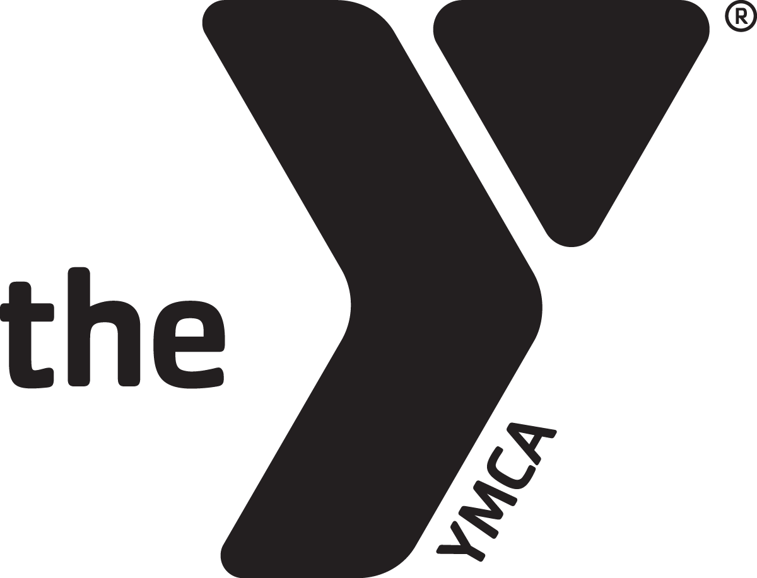
ADVOCACY PLAN

This Advocacy Plan is designed to facilitate collaboration between our YMCA Youth Advocates and their State YMCA Alliance staff/representatives who will be attending National Advocacy Days.

To start this process, Y-USA will send all Youth Advocates an email connecting them to their respective State YMCA Alliance staff/representatives, asking students to provide their availability for a call/virtual meeting with their alliance.

Youth Advocates will submit their Advocacy Plans online at www.ymcayag.org/yap by February 3, 2024, so schedule your call/meeting with that deadline in mind.

If you have difficulty scheduling your call, please email both elena.rocha@ymca.net and emily.perkins@ymca.net for assistance!

Part I. State Alliance Background

- Introductions & Y-Stories
Begin your call, with introductions by Youth Advocates & State Alliance staff/representatives, including how you got involved with the Y and any other stories you’d like to share.

- Overview of State Alliance Structure & Roles
How does your State Alliance function and serve the Ys in your state?

- State Alliance Resources & Materials
Please be ready to share any informational resources and materials on your State Alliance that will help your Youth Advocates better understand the impact of the Y across your state.

- State Alliance/Local Association Priorities
Do you have any statewide or local association priorities that your alliance wants to address in your Hill Meetings at National Advocacy Days? Discuss them so Youth Advocates can be prepared when they’re mentioned during Advocacy Days.

- Connections/Relationships to Congressional Offices
Do your Ys or staff have existing connections or relationships to their members of Congress (program alumni, former staff, current Y members or board members, etc.) Do your Youth Advocates have any existing connections/relationships on the Hill? Do any members of your state alliance delegation have special requests for their Representatives or Senators?

Part II. Hill Meeting Requests

Your state has 2 US Senators and a number of US Representatives proportional to your state’s population. Your State Alliance staff will schedule Hill Meetings with these offices during National Advocacy Days, including the Representative(s) serving the congressional districts of your state’s Youth Advocate(s).

Some State Alliances will have time to request meetings with all of their Members of Congress, while larger states will focus on a targeted group of offices.

- Requested Hill Meetings
List the names of all Senators and Representatives your State Alliance will request meetings with while in DC for Advocacy Days. Please ensure this request list includes either all of your Members of Congress OR (for larger states) enough offices to ensure you have meetings on both days available for meetings during National Advocacy Days, including the Representative(s) serving the congressional districts of your Youth Advocates.

- Confirmed Hill Meetings
List the names of all Senators and Representatives, as well as meeting dates/times, locations, and office staff, for all confirmed meetings you’ve scheduled for Advocacy Days. Please provide Youth Advocates with updates to this list as each meeting is confirmed.

Part III. Hill Meeting Role

Youth Advocates will learn about our Y-USA Legislative Priorities as part of their training sessions and receive this year’s priorities to review.

Each Youth Advocate, in consultation with their alliance staff/representatives, will select one (1) legislative priority that they’d like to advocate for as part of their role in your Hill Meetings.

Their role during your meetings will connect their story and their priority:

- Share Your Story
Youth Advocates will share their advocacy story – one that shows their connection to the Y and what they’re passionate about.

- Connect Story to Priority
Once you’ve shared your story, you’ll then connect it to your legislative priority. How does your story/experience inform or inspire you to advocate for the priority you selected?

- Advocate for Priority
Finally, you’ll finish by advocating for your priority and making the “ask” connected to your priority – support for funding, support or co-sponsor a bill, etc.

- Prepared Questions
In many cases, you’ll have the opportunity to ask Hill Staffers (or even the Member of Congress) questions during your meeting. These can be questions about their background (are they involved with the Y or do they have a Y story? How did they get involved in public service, etc.) or questions about your state, your priorities, or their role in the office. It’s good to have some ready just in case the opportunity arises.

- LinkedIn & Follow-up
Youth Advocates will create a LinkedIn page (if they don’t already have one) to help stay connected to the network they build while at Advocacy Days, and ensure they reach back out via email to thank Congressional staff they spoke with during Hill Meetings.

Part IV. Hill Meeting Outline

Finally, please provide Youth Advocates with an outline of how you’d like your Hill Meetings to flow that also incorporates their role as laid out in this plan. This outline should be flexible to adapt to different meetings/locations but help ensure Youth Advocates feel comfortable when preparing.

- YMCA Staff/Volunteer Attendees
What other YMCA Staff or Volunteers from local Ys and your State Alliance will be accompanying Youth Advocates during their meetings?

- Hill Meeting Agenda
Put together a rough meeting agenda that outlines a preferred speaking order for all of your staff/volunteers and youth advocates, as well as the topics/priorities they’ll be addressing during their portion of the meeting.

