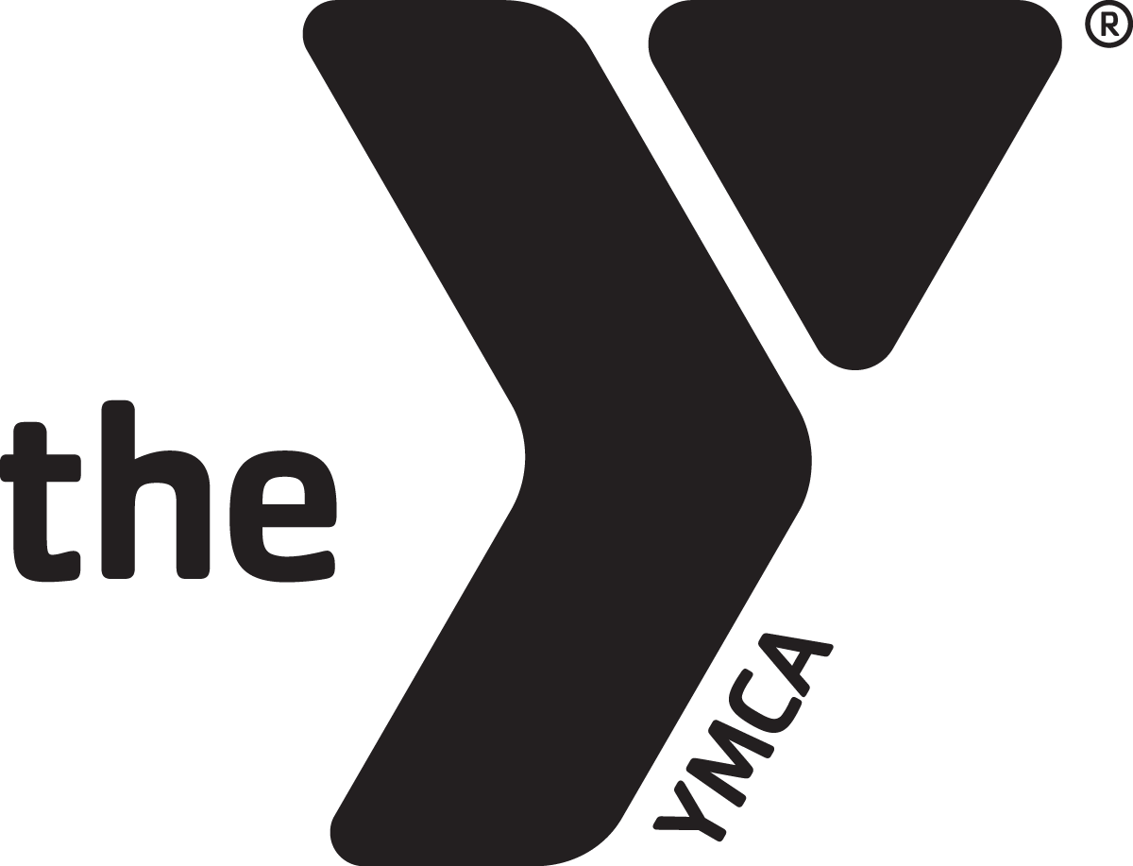
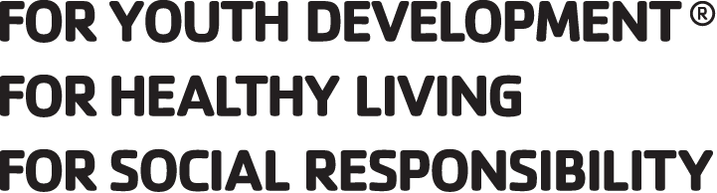

October 15, 2018
Dear [School Administrator Name(s)],

On Tuesday, November 6th, 2018, millions of Americans will head to the polls to cast their ballots in the 2018 Midterm Elections.

While elections bring a great deal of anticipation and uncertainty about the direction of our communities, state, and nation, one thing has remained constant across almost all elections over the past half-century: our youngest eligible voters don’t vote – especially in midterms.

In every presidential and midterm election since the voting age was lowered to 18 in 1972, voters age 18-24 have had the lowest turnout among all age groups. In midterm elections, turnout for young voters peaked at 26.6% in 1982, with an average turnout of only 22.7% compared to an average of 52.2% for all voters over age 25 (CIRCLE, 2016).

Decades of research have yielded many answers as to why young voters don’t show up at the polls, ranging from the simple (lack of interest/understanding of issues or disconnect with candidates) to the complex (institutional/legal barriers to voting or lack of a voting culture).

While many youth voter outreach efforts focus on voter registration (which remains a barrier for many young voters), on average, 78.6% of eligible voters are registered to vote (PEW, 2016). Voter Registration is important, but it does not predict turnout.

In most cases, voter turnout efforts are left to candidates, political parties, and partisan organizations. Campaigns and parties understand that young voters aren’t likely to show up, so youth are often ignored by costly partisan “get out the vote” (GOTV) efforts. This only exacerbates the issue and increases the turnout disparity with young voters.

To help provide a non-partisan solution to this issue, YMCA Youth and Government – the nation’s largest model government program for middle and high school students - has partnered with the National Association of Secretaries of State (NASS) to engage our YMCA Youth Secretaries of State in an effort to increase youth voter turnout.

This summer, 7 Youth Secretaries of State met alongside their official counterparts at the NASS Conference in Philadelphia to develop strategies they believed would help high schools increase voter turnout by young voters in not just the upcoming midterm elections, but in future elections as well.

With the midterm election only weeks away, this letter includes 10 non-partisan youth voter turnout strategies to help your high school ensure that all eligible students vote on November 6th.

This letter and list of strategies has been provided to all of our YMCA Youth and Government state programs – including [State Name] - to share with their student-led chapters and delegations, who can then present the information to administrators and faculty at their affiliated high schools.

With election laws varying from state to state (and county to county), we highly recommend that school leadership consult with local/state election officials on any specific questions and policies.

Thank you for your support of youth voter engagement in your school and community!

[Youth and Government Student Leader Name(s)]
[High School Name]
YOUTH VOTER TURNOUT STRATEGIES
10 Non-Partisan Strategies for High Schools to Increase Student Voting

- Identify Students Eligible to Vote on November 6, 2018.

- The most important step your school can take to help increase youth turnout is to determine which students at your school will be eligible to vote on Election Day.

- For administrators, this means pulling a list of students who were born on OR before Nov. 6, 2000. These students will be at least 18 years old, and eligible to vote.

- Once you have your list of eligible student voters, we’ve outlined several formal and informal options for reaching out to these students in the strategies below.

- Send a Letter Home to Eligible Student Voters & Families

- One of the easiest formal steps is to send a letter home (either distributed during classes, or mailed/emailed home) reminding eligible students and their families that they are encouraged to vote on Election Day.

- This letter should also outline any strategies your school will implement as part of your voter turnout strategy, so students/families anticipate them in the coming weeks.

- Offer Voter Registration during Class Time (If applicable in your state)

- Registration deadlines vary nationwide, so this may or may not be applicable in your state. Many states also have requirements about who can register voters and when.

- If your school is allowed to register students to vote, and the registration deadline has not passed, consider offering eligible students a final opportunity to register to vote during their English or Social Studies Classes on a day prior to the Election.

- Hold a School Assembly for Eligible Students

- If your school would rather talk to all eligible voters at once, send your list to faculty and ask them to dismiss students for a morning/afternoon assembly exclusively for eligible voters. If possible, invite a local election official to talk about voting.

- At the Assembly, discuss any additional strategies your school will be using to increase voter turnout, and let students speak to their peers about why voting matters.

- Set a School Goal Voter Turnout and/or District-wide Turnout Competition

- Once you know the number of eligible student voters at your school, your administration or Student Government can set a turnout goal for your school. Since ~22.7% of young voters usually turnout for midterms, you can set a goal of 75% that’s still triple the national average (but we encourage you to go higher!)

- Create incentives for reaching your turnout goal (i.e. free pizza day, dress-down days, faculty dunk tank, principal has to dye hair, etc.)

- If other high schools in your district set turnout goals, host a competition with the winning school getting a trophy/award to showcase until the next election/competition.
- Peer-to-Peer Non-Partisan GOTV Week by YMCA Youth and Government

- The week prior to the Election (Oct. 29 – Nov. 2nd), have the YMCA Youth and Government delegation at your school host a Get Out the Vote (GOTV) Week.

- Using the list of eligible student voters at your school, they’ll divide up the list of names and make sure they talk to every eligible voter at the school one-on-one during the week. During their GOTV conversations, they will:

- Ask their peers to vote, and talk to them about increasing youth voter turnout
- Help peers identify their polling place and plan what time they’ll be voting
- Once they’ve met with a peer, they will mark them as completed on the list.

- Ensure Sample Ballots are posted in Common Spaces and/or Classrooms

- In conjunction with posting flyers reminding students to vote, schools should also post sample ballots (ask local election officials) in common spaces and classrooms so students can review the different offices and candidates they’ll be able to choose from.

- Remember to only use official non-partisan sample ballots, and avoid partisan voter guides that are often available from campaigns, parties, and interest groups.

- Require Athletics/Extracurriculars to Excuse Students from Practice/Meetings

- A common excuse for student voters is that voting conflicts with afterschool sports or extracurricular activities that often require attendance at meetings or practices.

- School Administration should require all athletic and extracurricular activities to notify their participants that practice/meetings on Election Day are not required and are officially excused by the school to ensure they have time to vote.

- Celebrate Election Day

- Make sure that Election Day at your school is a celebratory atmosphere, ensuring that all students – not just those who are eligible to vote – know it is Election Day.

- Consider engaging Extracurricular Organizations like YMCA Youth and Government to decorate hallways the night before Election Day, or host a mock election for students who aren’t yet eligible to vote.

- For a school-wide celebration, consider hosting a non-partisan #VoteTogether Event on campus during lunch or immediately after school (as eligible students leave to head to the polls). You can register your event at www.votetogetherusa.org

- Ensure Opportunities for Student Voting on Election Day

- Ultimately, the best way to ensure that your eligible student voters turn out to vote is to create as many opportunities to vote as possible.

- While there are many ways schools can proactively promote student voter turnout, here are a few of the most effective:

  - Election Day Early Dismissal: Give eligible students a half-day off to vote, with early dismissal to allow for time to get the polls.

  - Rides to the Polls: Reserve a bus or other transportation to drive students to polling locations during the day. This can take some time with multiple polling locations, but can make it a fun trip for students to vote together.

  - Student Vote Pass: Allow students to arrive late or leave early with a “Vote Pass” they can secure on Election Day from the school office.

